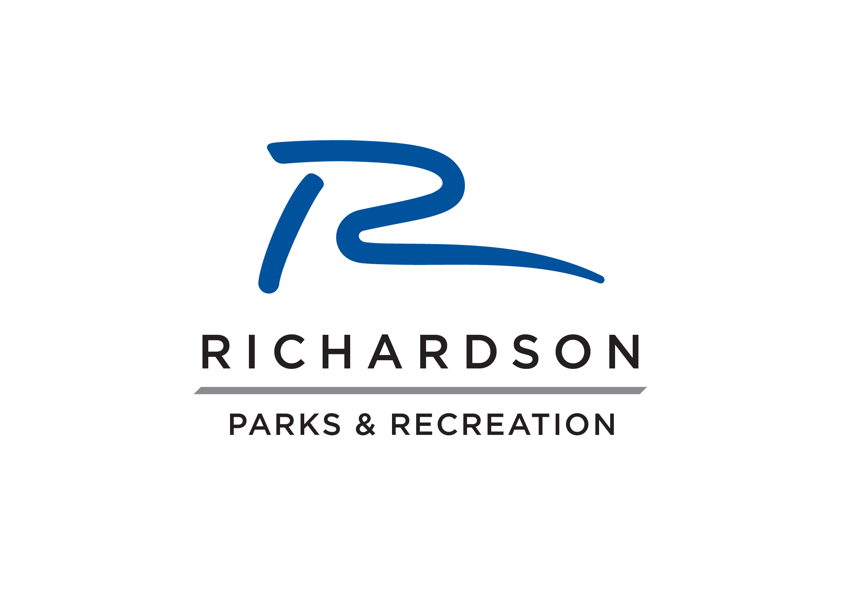
Matching Fund Beautification Program
Application
(Applications must be received by March 1 of each year)

Date: ________________________________

Name of Organization: ________________________________________________________

Contact Person: ______________________________________________________________

Address: ____________________________________________________________________

Phone:___________________________ Email:________________________________

Alternate Contact Person: ______________________________________________________

Address: _____________________________________________________________________

Phone:___________________________ Email:________________________________

Expected Budget (your cost): ____________________________________________________

Brief description of proposed project:

