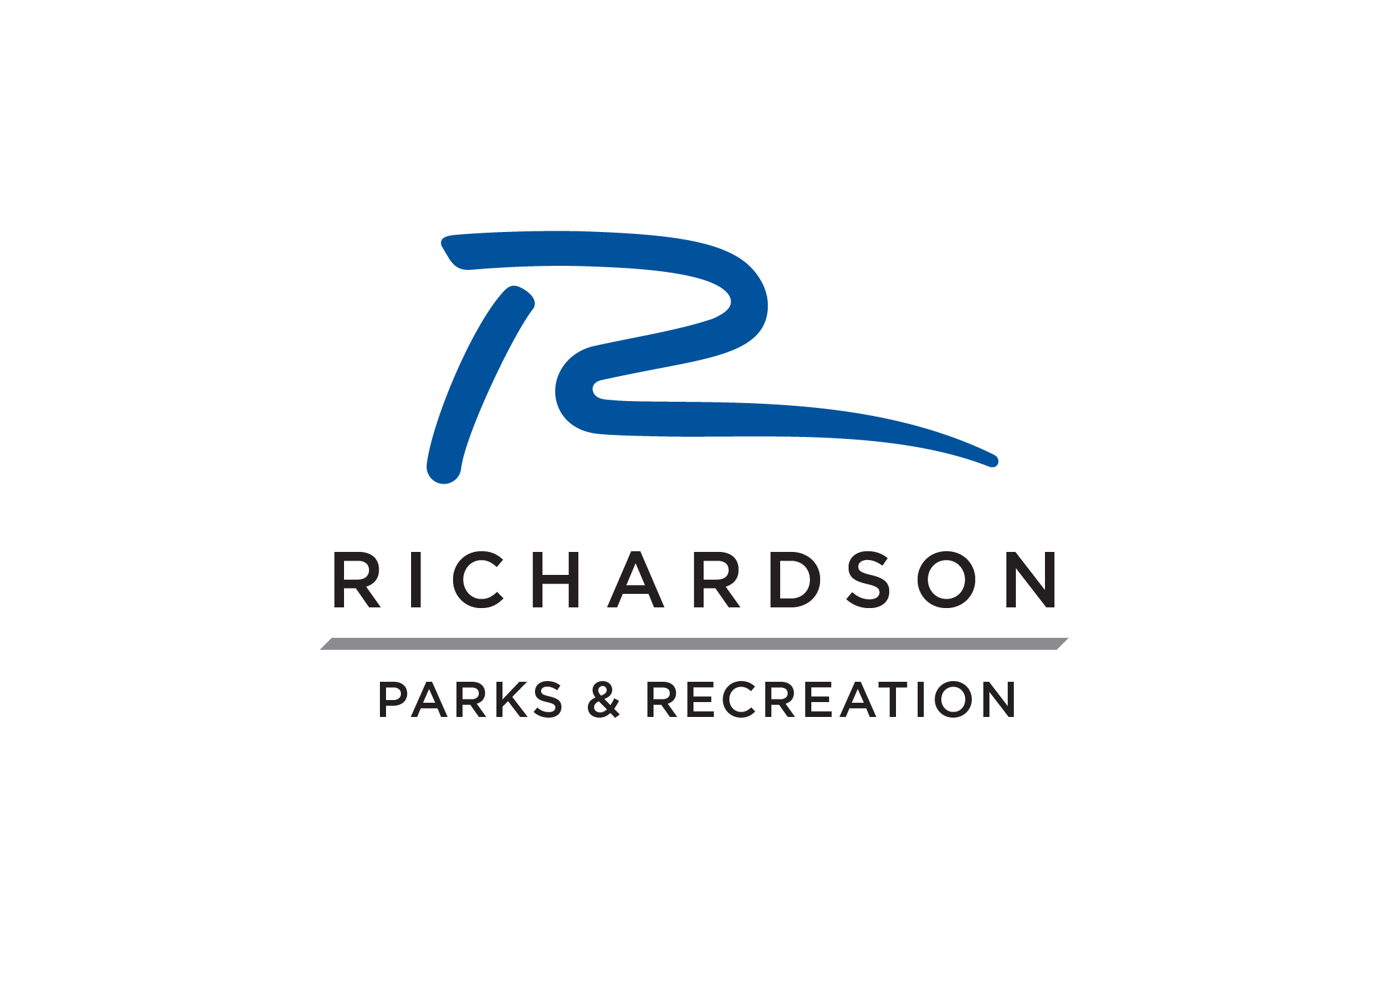
City of Richardson Matching Fund Beautification
Project Description Form

Name of Organization: ________________________________________

Contact Person: ________________________________________

Phone: ________________________________________

Today’s Date ________________________________________

In order to help us develop an accurate cost estimate for your project, please list as much information including sketches / drawings, exact locations, photos, and / or plant / tree selections. Please feel free to add additional pages if needed.

Project Description

Location:

Desired Plants / Trees / Groundcovers:

Desired Flatwork (regular concrete / colored-stamped concrete / stone work):

Comments:

